## Power Battery Connection and Disconnection Issue

1. Relay control for power connection and disconnection. To ensure that the power battery does not disconnect due to a single switch failure, at least two control methods are required. It is preferable for them to be normally closed to prevent discomfort caused by the relay closure sound during each startup. However, maintaining a normally closed state may lead to another issue, which is the power consumption problem of the relay. According to the EV200A1ANA\_1618002-1 datasheet ([https://www.te.com/usa-en/product-1618002-1.datasheet.pdf](https://www.te.com/usa-en/product-1618002-1.datasheet.pdf" \t "_new)), the specified power consumption is 1.7W@12V, equivalent to a current of I=141.666mA. However, my actual test shows that the relay measures a full power current of 3.3A (39.6W) at 12V, with a minimum operating voltage of 12V/1.5A (18W). Therefore, certain requirements exist for the battery.
2. Backup Power Battery In case of thermal runaway or any issue requiring immediate disconnection of the main power battery, a backup power battery should be activated. Considerations need to be made regarding the range of the backup power battery.
3. Safety Detection Is it necessary to perform real-time detection of altitude (to prevent power battery depletion during high-altitude flight and activate the backup battery for forced descent)? Additionally, collision detection and automatic obstacle avoidance need consideration (considering the booming market for autonomous driving vehicles in China, it might become a selling point for the product).
4. Relay Drive Module To achieve disconnection under high voltage, it is necessary to disconnect the high-voltage circuit relay, thereby disconnecting the high-voltage circuit between the power battery and the motor. The high-voltage circuit generally includes three relays: main negative relay, main positive relay, and pre-charge relay. During high-voltage activation, the main positive/main negative relays are in a closed state, while the pre-charge relay is in an open state. 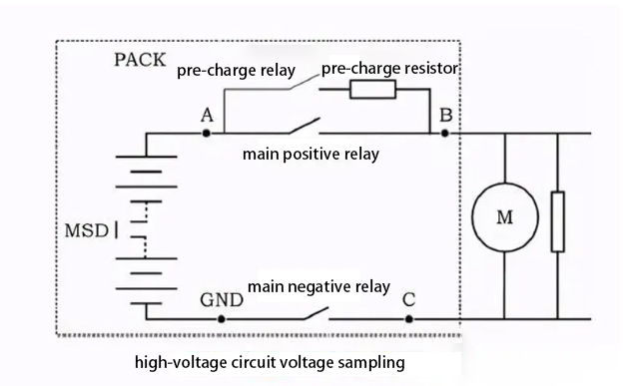

## Main Functions of BMS

* 1. Parameter Detection Real-time collection of battery charging and discharging status. Collected data includes total battery voltage, total battery current, temperature at each battery cell point, and individual module battery voltages.
  2. State of Charge (SOC) Estimation
     1. SOC calculation at the cell level (most accurate SOC calculation within software, no involvement of filtering).
     2. SOC calculation at the module or battery pack level (mapping from cell-level SOC to module or pack level SOC, determining whether the pack's SOC is closer to SOCmin or SOCmax of the cells).
     3. Final presented SOC calculation for the customer display (client-side display remains within 0%-100%, without increasing during discharging, decreasing during charging, or abrupt changes; mapping the cell's usable range (20%-90%) to 0%-100%, involving filtering algorithms, etc.). Battery remaining energy is analogous to the fuel level in traditional vehicles. To allow drivers to promptly understand SOC, the system should instantaneously collect parameters like charging and discharging currents, voltage, etc., and estimate SOC using appropriate algorithms.
  3. Charge and Discharge Control

Control of battery charging and discharging based on battery's charge status. If any parameter exceeds the limit, such as individual cell voltage being too high or too low, to ensure normal battery group use and performance, the system will cut off relays, stop supplying energy to the battery, and activate the backup power battery.

* 1. Thermal Management

Real-time collection of temperature at each battery cell point, controlling cooling fans to prevent the battery from reaching excessively high temperatures.

* 1. Balancing Control

Due to differences between individual battery cells and variations in their usage, battery inconsistency can worsen during usage. The system should be able to detect and automatically perform balancing processes.

* 1. Fault Diagnosis

Through data collection of battery parameters, the system has functionalities for predicting battery performance, fault diagnosis, and early warning systems.

* 1. Information Monitoring

Key battery information is displayed in real-time on the onboard display terminal.

* 1. Parameter Calibration

Since different vehicle models or aircraft utilize different battery types, quantities, sizes, and pack numbers, the system should have calibration functionalities for vehicle (aircraft) types, vehicle (aircraft) identification numbers, battery types, and battery modes. BMS communicates with calibration software on the upper computer via the RS232 interface.

* 1. CAN Bus

Interface Sharing information with other vehicle (aircraft) systems based on the vehicle (aircraft) CAN communication protocol.

## BMS electrical architecture.

BMS Electrical Architecture For the distributed BMS, it consists of 1 main controller, 1 high-voltage controller, 2 sub-controllers, and related sampling control harnesses, which facilitate information exchange among controllers via the CAN bus.

1. Main Controller

Processes information reported by sub-controllers and the high-voltage controller, determines and controls the operational status of the power battery based on the reported information. Implements BMS-related control strategies, and conducts fault diagnosis and handling accordingly.

1. High-Voltage Controller

Real-time collection and reporting of total power battery voltage and current information. Utilizes its hardware circuitry for timely integration, providing accurate data for the main board to compute State of Charge (SOC) and State of Health (SOH). Additionally, capable of performing pre-charge detection and insulation monitoring functions.

1. Sub-Controllers

Real-time collection and reporting of individual cell voltage and temperature information of the power battery. Provides feedback on SOH and SOC for each cell series, simultaneously equipped with passive balancing functionality, effectively ensuring consistency in cell usage during power utilization.

1. Sampling Control Harnesses

Provide hardware support for various information collection from the power battery and facilitate information exchange among controllers. Additionally, includes redundant safety features on each voltage sampling line, effectively preventing external short circuits caused by harness or management system issues that may affect the battery.

## BMS Control Methods窗体顶端

1. 窗体顶端

A complete and reasonable BMS control method is crucial to ensure the power battery's safety, reliability, optimal performance, and longevity. The primary control methods of BMS include the following:

1. Operating Modes Control

BMS comprises the following five operational modes:

* 1. Power-off Mode:

The power-off mode is a state where both the low-voltage and high-voltage sections of the entire system are inactive. In this mode, all high-voltage contactors controlled by the BMS remain in the open state, and the low-voltage control power supply remains unpowered. The power-off mode is a power-saving mode.

* 1. Standby Mode:

In this mode, BMS doesn't process any data, consumes extremely low power, and is quickly restartable. In standby mode, all contactors in the system are in the unengaged state. During this mode, the system can receive hardwire signals from external components like ignition lock, vehicle control unit, motor controller, charging plug switch, or low-voltage signals controlled by CAN messages to drive the high-voltage contactors, allowing the BMS to enter the required working mode.

* 1. Discharge Mode

When the BMS detects a discharge WAKEUP signal in standby mode, it receives operational status instructions for the power battery from the Vehicle Control Unit (VCU) and action commands for the contactors. Subsequently, it executes the relevant instructions, completes the BMS power-on and pre-charge processes, and enters the discharge mode. In this mode, the B-Contactor closes first upon detecting the high-voltage power signal Key\_ST from the ignition lock. To prevent excessive current surges in the motor (as it's an inductive load), after closing the B-Contactor, the pre-charge contactor closes for pre-charging. When the voltage across the pre-charge capacitor reaches 95% of the bus voltage, the B+ Contactor immediately closes, and the pre-charge contactor opens, entering the discharge mode.

* 1. Charging Mode

In standby mode, upon detecting a charging WAKEUP signal, the BMS receives operational status instructions for the power battery and action commands for the contactors from the VCU. Subsequently, it executes the relevant instructions, completes the BMS charging process, enters the charging mode, and communicates with the onboard charger. Upon detecting the Charge Wake Up signal, the system enters the charging mode. In this mode, both the B-Contactor and onboard charger contactor close, and to ensure continuous power supply to the low-voltage control system, the DC conversion contactor operates. In the charging mode, the system doesn't respond to any commands from the ignition lock. The charging wake-up signal from the charging plug serves as a basis for determining the charging mode. Due to poor charging characteristics of lithium iron phosphate batteries at low temperatures, there is a certain risk associated with charging lithium batteries at low temperatures. For safety reasons, a temperature check should be performed before entering the charging mode. When the battery temperature is below 0°C, the system enters the charging pre-heating mode, supplying power to the low-voltage battery through the DC conversion contactor and allowing the battery module to preheat. When the temperature inside the battery pack reaches and exceeds 0°C, the system can enter the charging mode by closing the B-Contactor.

* 1. Fault Mode:

When the BMS detects any faults in any mode, it enters the fault mode and reports the fault status and related fault codes to the VCU. The fault mode is a common state in the control system. As the use of vehicle batteries directly relates to user safety, the system prioritizes safety in response to various modes. The BMS response to faults also depends on the fault level. When the fault level is relatively low, the system may issue error messages or minor warning signals to notify the driver. However, in the case of higher fault levels or when there is an associated danger, the system adopts a control strategy to directly disconnect the high-voltage contactors. The voltage battery is the power source for the entire vehicle control system. Whether in charging mode, discharge mode, or fault mode, the closing of the DC conversion contactor enables the low-voltage battery to remain in the charging mode, providing continuous low-voltage power supply.

1. Pre-Charge Control Method

When the BMS detects the pre-charge enable signal sent by the VCU in the power-on state, it closes the relevant pre-charge contactor and provides feedback on the contactor status. Simultaneously, it monitors the power bus voltage, compares it with the power battery voltage, and when the power bus voltage reaches reasonable conditions, the main positive contactor is closed, cutting off the pre-charge circuit, thereby completing the pre-charge process.

1. Charge and Discharge Control Method

By analyzing the charge and discharge power characteristics of the battery cells and considering the charge and discharge capabilities of the power battery under different environments and operating conditions, reasonable charge and discharge conditions and thresholds are proposed. This includes controlling battery charging and discharging in terms of discharge current, voltage, temperature, charging current, voltage, temperature, as well as total voltage upper limit, total voltage lower limit, single-cell voltage upper limit, single-cell voltage lower limit, current upper limit, current lower limit, temperature upper limit, temperature lower limit, and insulation. Additionally, each control threshold has secondary redundant protection to improve the safety of power battery charging and discharging. Based on environmental temperature, power battery State of Health (SOH), State of Charge (SOC), and available charging power, different dimensions are controlled to set fast charging conditions and thresholds for the power battery.

1. Thermal Management Control Method

Based on the environmental temperature and power battery temperature information reported by the BMS controller, the charging and discharging capabilities of the power battery are thoroughly assessed, and relevant heating and cooling devices are controlled to be activated or deactivated. The commonly used thermal management system is air cooling, with modes divided into charge thermal management and discharge thermal management. The cooling function has two modes: battery thermal management and integrated air conditioning thermal management. The battery thermal management solely starts the internal cooling device of the power battery, while the integrated air conditioning thermal management simultaneously activates the entire vehicle air conditioning system and the internal cooling device of the power battery.

1. SOC Estimation and Correction Method

By sampling and integrating the current using high-precision current sensors, the basic calculation method is as follows:

窗体顶端

In the equation: SOC0 represents the initial state of charge; C0 denotes the rated capacity of the battery; ibatt stands for the charging/discharging current of the battery, and η represents the charging/discharging efficiency of the battery.

Due to the complexity of vehicle driving conditions and the limited accuracy in current measurement, coupled with the impact of temperature changes on battery capacity, it is challenging to accurately calculate SOC. Therefore, several correction strategies have been developed(Open Circuit Voltage ,OCV) Correction: Estimate the current SOC based on the relationship model between individual battery voltage and SOC at different temperatures. The following figure depicts the OCV correction model under normal temperature (25°C).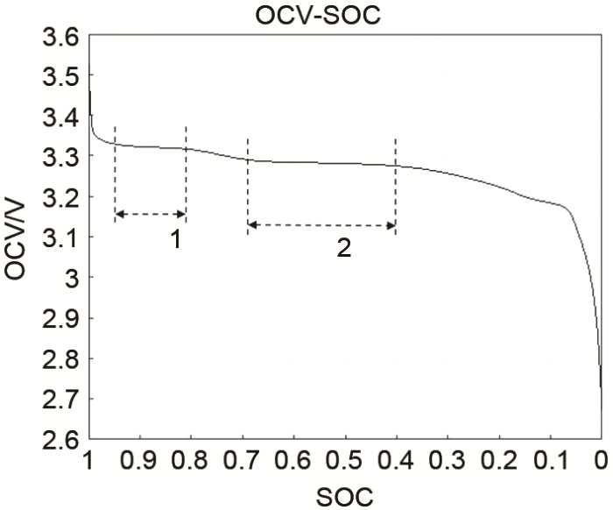

1. SOC Dynamic Correction Considering various vehicle conditions, establish a model correlating the individual cell voltage of the power battery during charging and discharging with the State of Charge (SOC) at different temperatures to estimate the current SOC. The following figure illustrates the SOC dynamic correction model under different temperatures.
2. Charging Correction Based on the SOC dynamic correction, under relatively stable charging conditions, estimate the current SOC by establishing a model relating the individual cell voltage of the power battery to SOC. The following figure represents the charging correction model at normal temperature (25°C).
3. Fault Diagnosis Method

As vehicles operate over extended periods, issues such as power battery short circuits, open circuits, deterioration in electrical performance, overcharging, over-discharging, and insufficient ventilation systems may arise. Therefore, a reasonable fault diagnosis mechanism is particularly crucial. Through BMS monitoring and electrical system hardware matching, effective faults are identified reasonably, providing safety warnings or protective strategies. Each fault is assessed with a three-level redundant judgment: minor fault, severe fault, and critical fault.

1. Safety Monitoring Method

Safety monitoring is achieved through related software code implementation to assess the functional failure of external hardware circuits and functional components. Its purpose is to add a layer of software redundancy protection to the power battery, ensuring the vehicle's safer and more reliable operation. The specific details are illustrated in the following figure. By monitoring parameters such as voltage, current, temperature, time, communication data, and analyzing relationships between different pieces of information, the BMS processes and identifies potential failure modes.

## BMS Hardware Design

Based on the composition of the BMS, the system's hardware design mainly includes modules such as data acquisition, communication, safety control, and thermal management. Let's take a look at the hardware design.

1. Data Acquisition Circuit Design

The accuracy of voltage and current measurements directly impacts the precision of State of Charge (SOC) estimation. The figure below illustrates the voltage sampling circuit. After primary filtering by the positive and negative bus voltages composed of L1 and L2, sampling is carried out via R1, R2, R3, and RP sampling circuits. Subsequently, the voltage is converted into a 0~5V signal through resistance amplification based on LM258 and transmitted to the MCU's A/D port. Due to the high bus voltage, a protection circuit comprising D1 and D2 is integrated to ensure the safe operation of the microcontroller. Isolation from ground is essential during battery cell voltage sampling. In this design, AQW214EH optoMOS switches are used for cyclic sampling of individual battery cells, ensuring only one cell voltage is sampled at any given time. This not only enhances system reliability but also reduces costs. Current sampling is achieved through a Hall effect current sensor. The output signal undergoes division, comparison, and amplification before being processed by the MCU.

1. Communication Module Design

Compared to general communication buses, CAN bus data communication exhibits outstanding reliability, real-time performance, and flexibility, hence its widespread application in automotive electronics. The system's microprocessor PIC18F4585 includes a CAN controller and utilizes the PAC82C250 chip as the CAN bus transceiver. The BMS communicates with other control modules such as the Vehicle Control Unit (VCU) via CAN. To ensure communication quality, a 6N137 chip for optocoupling is integrated between the CAN transceiver and microcontroller, while the CAN-dedicated power supply isolates signal ground and analog ground. Additionally, for ease of system parameter debugging, a UART port is reserved for communication with a computer.

1. Safety Control Module Design

The total voltage of electric vehicle power batteries typically exceeds 300V, necessitating the design of a safety control module.

Before connecting the battery to the vehicle, the system closes the pre-charge sensor, introducing a large resistor R into the battery bus through the pre-charge relay. Other parameters are monitored to ensure normal vehicle operation before disconnecting the pre-charge relay, closing the bus relay, and directly connecting the battery to the vehicle. A leakage current Hall sensor is used to detect system leakage faults. Both positive and negative bus lines pass through the Hall sensor. In case of a system leakage fault, the algebraic sum of the currents in the positive and negative buses will not be zero, leading to a current signal output from the Hall sensor. In this system, when the current signal exceeds 25mA, the leakage detection circuit sends an interrupt request to the CPU. The CPU responds to the interrupt, cutting off the bus relay, and transmitting the fault information to the Vehicle Control Unit (VCU).

1. Thermal Management Module Design

The location of the battery pack and external conditions may lead to uneven temperature distribution. Non-uniform temperature distribution can cause voltage imbalances between battery cells, affecting both battery and vehicle performance. The primary method for battery temperature balance involves ventilation treatment and the use of heat dissipation plates. Finite element analysis is used to analyze parallel and series ventilation. The results indicate that parallel ventilation is significantly more effective than series ventilation. Six digital temperature sensors, DS18B20, are installed at different positions within the battery pack. Every second, the system samples the DS18B20 via the bus. When detecting any point's temperature or its rate of change exceeding a set value, the variable-speed fan is activated. The fan stops only when all points' temperatures and their rate of change are below the set value.

1. Hardware Anti-Interference

Design Strong electromagnetic interference from other vehicle equipment and during charging can lead to a large amount of data mis-collection in the BMS. Thus, the following anti-interference measures are implemented: a) High-frequency bypass capacitors are connected between the battery pack and the vehicle and within the BMS power interface circuit to eliminate common-mode interference. b) High-speed digital isolators, ISO721, are added between sub-boards and templates to prevent overvoltage from sub-boards impacting the mainboard.窗体顶端

## BMS Software Design

1. BMS Software Flow

The design approach to effectively manage the power battery. Functionally, the system software design is divided into several parts: initialization, data acquisition, temperature control, SOC estimation, CAN communication, and interrupt service. The system interrupt response service program includes external interrupts such as overcurrent and leakage. If the pre-charge test fails or the battery voltage exceeds a safe limit, the system also triggers an interrupt response to ensure vehicle and occupant safety. Considering the harsh electromagnetic environment within electric vehicles, this design completely avoids using multiple branch statements to reduce electromagnetic interference on the system. It connects to an upper computer via RS232 to facilitate system parameter calibration, observe voltage, current, temperature, SOC estimation, etc.

1. Software Anti-Interference Design

The BMS operates in a harsh electromagnetic environment, susceptible to various electromagnetic signals like IGBT and power diode frequent conduction cutoff disturbances, which directly impact data acquisition accuracy, reducing system reliability and stability. Hardware anti-interference measures are complemented by software filtering for this type of interference signal. This not only enhances filtering effectiveness but also reduces system costs.